# Upgrade from Forticlient VPN 6.4 to Version 7

KI 0877

The below instructions is for users running version 6.4 of the FortiClient. This version unlike older versions can be upgraded to version 7.0.

**Download Forticlient**  
  
The installation file is available at the following location  Forticlient version 7.0  
  
<https://ulcampus-my.sharepoint.com/:u:/g/personal/service_deskitd_ul_ie/ETJY5aKfB5lMhMsOywi1GwEBtsbgCrf_WYR3yQr0B-IbKA?e=YGcoMx>  
  
  
**Install Forticlient**  
  
Run the Installation program

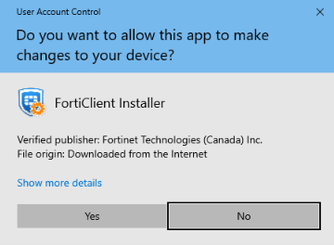

Click Yes

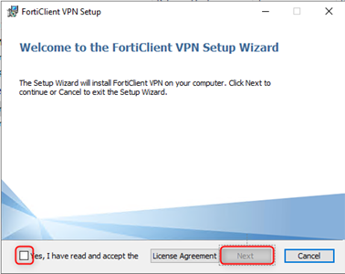

Accept, and click Next

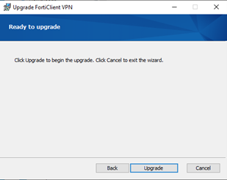

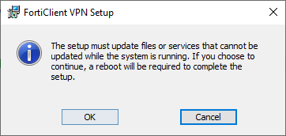

Click Ok when prompted

**How do I configure version 7?**  
  
1. Select Configure VPN or Add new Connection (If an existing profile exists)  
2. Set the below settings as seen in the image.

1. Verify SSL-VPN is selected
2. Connection Name: UL SAML (Can be set to anything)
3. Remote gateway: ulssl.ul.ie
4. Tick “Enable Single Sign On (SSO) for VPN Tunnel”

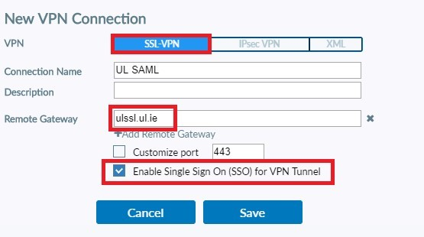

1. Click Save
2. Select the name you gave your SAML configuration in the drop-down menu and then click “SAML Login”

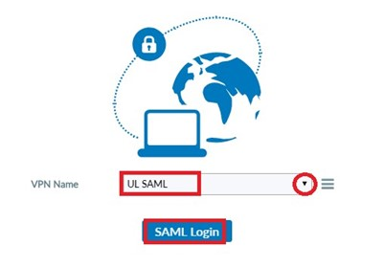

1. You will be prompted for your username. (Enter your email address)  
    e.g. Username: first.last@ul.ie (**N.B** must include @ul.ie)

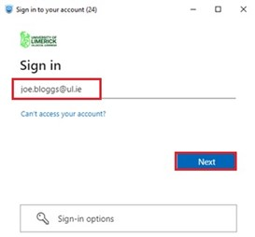

6. You will then be prompted for your password.   
  
        a.    Password: Enter your email password

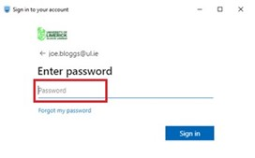

7. Approve sign in request on your mobile device. This is multi factor authentication and is the same method you would follow for approving a request when logging into your email.

* Non ITD managed / Public machines **N.B don’t tick this option** as it will store these credentials on this device.
* ITD Managed machines only can select this option “Don’t ask again for 60 days”. You will not be prompted for a username and password the next time you connect.

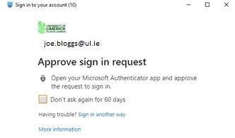

8. For the following screen select

* Non ITD managed / Public machines **N.B select No** to prevent another user on that machine using your account to connect to the ssl vpn.
* ITD Managed machines only can select Yes. You will not be prompted for a username and password until your token expires.

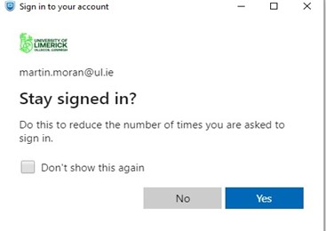

9. You should now be connected to the ssl vpn using SAML.

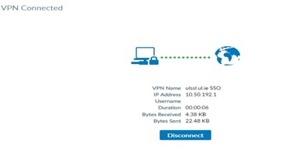

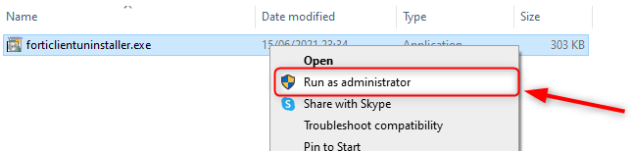Top of Form

Bottom of Form